**EXPERIMENT - 4**

**Aim** :

To realize binary to gray code converter and gray code to binary converter

**Apparatus / Equipments :**

* Breadboard
* Connecting Wires
* Resistors
* LEDs
* Power Supply (DC)
* IC 7486 (XOR)

**Theory :**

Binary Numbers is default way to store numbers, but in many applications binary numbers are difficult to use and a variation of binary numbers is needed. Gray code is an ordering of the binary numeral system such that two successive values differ in only one bit (binary digit). Gray codes are very useful in the normal sequence of binary numbers generated by the hardware that may cause an error or ambiguity during the transition from one number to the next. For example, the states of a system may change from 3(011) to 4(100) as- 011 — 001 — 101 — 100. Therefore there is a high chance of a wrong state being read while the system changes from the initial state to the final state. This could have serious consequences for the machine using the information.

So, the Gray code can eliminate this problem easily since only one bit changes its value during any transition between two numbers. Gray code has property that two successive numbers differ in only one bit because of this property gray code does the cycling through various states with minimal effort. It is used in K-maps, error correction, communication etc. In computer science many a times we need to convert binary code to gray code and vice versa. This conversion can be done by applying following rules:

**Binary-to-Gray Code Conversion**

The following rules explain how to convert from a binary number to a Gray code word:

1. The most significant bit (left-most) in the Gray code is the same as the corresponding MSB in the binary number.

2. Going from left to right, add each adjacent pair of binary code bits to get the next Gray code bit. Discard carries. (i.e. we are XOR-ing consecutive binary input bits)

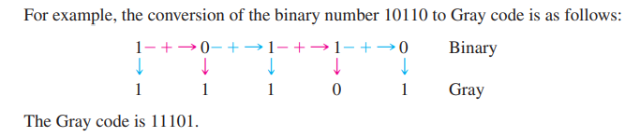

**Gray-to-Binary Code Conversion**

To convert from Gray code to binary, use a similar method; however, there are some differences. The following rules apply:

1. The most significant bit (left-most) in the binary code is the same as the corresponding bit in the Gray code.

2. Add each binary code bit generated to the Gray code bit in the next adjacent position. Discard carries. (i.e. we are XOR-ing the previously generated binary bit with the next gray bit).

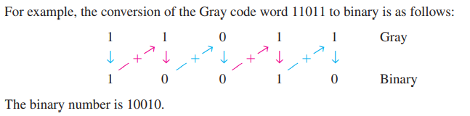

**Procedure:**

1. Assemble the circuits on the breadboard as per the circuit diagrams. The breadboard should also be grounded and connected to a power supply.
2. The ICs are to be connected properly to a power supply and ground following the schematics for the ICs.
3. Input combinations should be provided using the connecting wires by connecting to ground for a LOW value and power for HIGH value to be given to the IC input.
4. Turn on power of the experimental circuit.
5. Apply various combinations of inputs in the form of binary/gray numbers via the IC inputs.
6. Compare results with the table.

**Conclusion:**

Thus, we have designed a Binary to Gray converter and a Gray to Binary converter and verified the truth table.